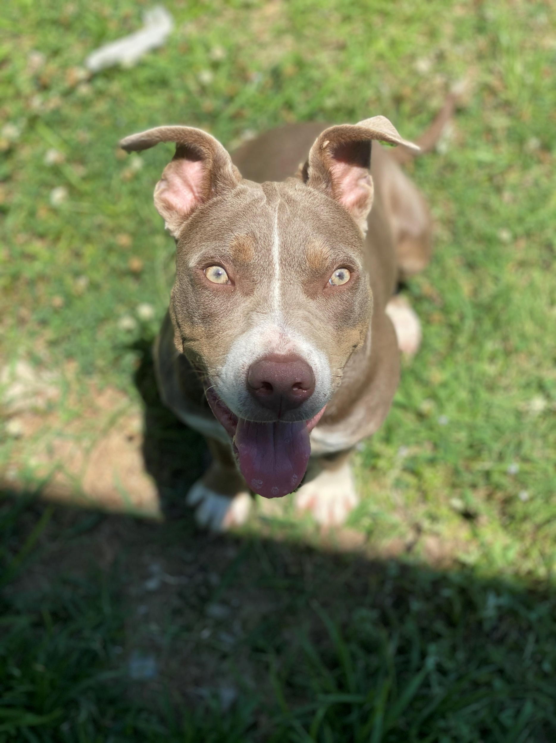

VOLUNTEER HANDBOOK
Table of Contents

Welcome to TMAS!...................................................................................................................4
- Welcome and Thank You!
- About TMAS / Mission & Vision Statement
- What does TMAS do?
TMAS Team……………………………………………………………………………………………9
- Contact Information
- Our Staff Commitment to You
The TMAS Volunteer Experience………….……………………………………………………….11
- What Can You Do for TMAS?
- Volunteer Benefits
- Age Requirements
- Open House
- Process to Volunteer at TMAS
Scheduling Your Service………………………….…………………………………………………13
- You Must Be on the Schedule to Participate
- Daily Closing Time
- Log Your Daily Service Hours
- Missing Shifts / Your Commitment
Code of Conduct…………………………………………………………………………………...…14
- Respectful behavior
- Non TMAS guests/pets
- Privacy Policy and Conveying Correct Information
- Dress code
- Parking
- Smoking
- Drugs and alcohol
- Cell phones
- Animal care
- Injuries
- Complaints
- Volunteer Performance Support / Causes for Release from Volunteer Service
- Volunteer Term

Working with and representing TMAS…………………………………………………………......18
- Social Media
- Media Contact and Public Commentary
- Understanding Euthanasia
- Disease Control
Community Groups & Events…………………………………………………………………….…20
- Volunteer Groups, Clubs, or Organizations Wishing to Volunteer
- Volunteers Wishing to Help at Events
Volunteer Training……………………………………………………………………………………21
- Pairing with mentors / Staff in Specific Areas
- Playgroups
Volunteer Jobs…………………………………………………………………………………….…22
- Ambassador
- Adoption Counselor
- Animal Care Assistant (bathing, brushing, cleaning cages, enrichment, bottle feeding, etc.)
- Cat Cuddler
- Dog Walker
- Happy Hour Participant
- Happy Hour Program Assistant
- Foster Program Assistant
- Maintenance Team (Dishwashing, laundry, sweeping, dusting, grass cutting, etc.)
- Petsmart Team (clean cages at Petsmart daily)
- Volunteer Coordinator Assistant
- Playgroup Volunteer
- Video / Photography
- Events
- Transport Driver or Event Driver
Community Support………………………………………………………………………………….37
- Donations
- Fundraisers
- Sponsorships
General Information……………………………………………………………………………….…39
- Requests for animal help
- Conflicts of interest
- Harassment Policy and Grievance Procedure
- Confidentiality and Nondisclosure Policy

Welcome to TMAS!

Welcome to the Metro Animal Shelter’s Volunteer Program. Being a volunteer is extremely rewarding, educational and fun. You can have a significant positive impact on the lives of homeless animals. Walking a dog, cuddling a cat, giving a treat or blanket or giving a simple pat on the head will touch your heart and bring you back for more. It is especially rewarding to see how the animals respond immediately to the love they receive while they are at the shelter. As a result of the volunteer program, dogs get walked regularly and cats are more socialized. Animals get placed in foster homes when they are too young to adopt or need to recuperate from injury or illness; or just need a little more socialization. Most importantly, because of volunteers, many dogs’ and cats’ lives are saved. The Metro Animal Shelter Volunteer Program was created for the animals.

Thank You!
Thank you for giving us your time and for giving the animals your attention! We appreciate your commitment to help us help them and we know that your time is valuable. Each of you may have different reasons for wanting to be a volunteer, but all of you choose to volunteer at TMAS because:
- You desire to care for those cats and dogs desperately needing positive human interaction
- You wish to help find homes for animals that deserve a second chance
- You want to be a part of making our community more responsible for our pets
- You want to help save lives
As a volunteer, you are an asset to our organization and to the many animals which need loving homes. Our goal is to continually expand our community outreach program, placing more animals into good homes. The time and energy you contribute by volunteering helps us achieve these goals. Since your support as a volunteer is extremely important, your decision to participate must be made with the full understanding of the commitment and responsibility it demands. This handbook has been prepared for you as a reference guide. It contains information regarding our policies & procedures, tools for dealing with the public and how to safely handle shelter animals. Please read it carefully so you will be well equipped to answer questions knowledgeably and to provide quality care to the animals at the shelter. Thank you for giving your time and energy to the animals at TMAS. We hope that the time you spend here will be as rewarding to you as it is beneficial to the animals you help.

About TMAS

Metro Animal Shelter, Inc. opened its doors in July, 1994, in the building that is now Averette Veterinary Hospital. In October, 1999, we moved to our present location. The shelter was founded on the ideals that we wanted to give the best possible care to the animals at our facility, no matter how short or how long their stay with us may be.

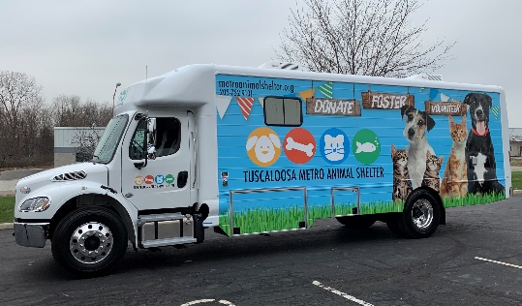
We are a 501c (3) non-profit agency. We bid on a contract every three years to manage the shelter. We are funded by a tri-government entity made up of the City of Tuscaloosa, Tuscaloosa County Commission, and the City of Northport. The funds received from the governments enable us to maintain this shelter building, cover payroll for its employees, and general operating expenses. Along with these funds, we also receive donations, redemption, and adoption fees.

TMAS is dedicated to pet adoption and live release. In addition to sheltering and providing veterinary care to animals brought to the shelter, we work diligently to place these animals in new homes. We collaborate and coordinate with our Pet Rescue groups and through social media networks to cast the widest possible adoption net. We are committed to promoting responsible pet ownership through spaying/neutering, microchipping, vaccinations, education programs, and events. Campaigns and programs to educate and raise community awareness about these services are ongoing.

Mission Statement

Our mission is to provide resources, programs, and information needed to build a more humane community that values animals and promotes compassion and kindness towards them, embraces responsible pet ownership, and promotes the animal/human bond.

Having a more humane community will directly impact our fight in eliminating unnecessary euthanasia.

Vision Statement

Our vision is to inspire community involvement in animal welfare and motivate the public to embrace responsible lifelong pet ownership.

What Does TMAS Do?

Placement of Pets through Adoptions & Rescue Groups
- We make dogs and cats available for adoption at our shelter and at various off-site adoption events throughout the city and county.
- Standard adoption fees:
Dogs/Puppies: $100
Cats/Kittens: $50
Other: $10
We do provide discounts for certain lengths of stay, military and senior discounts on full cost adoption fees.
- Animals are also transferred to registered rescue groups.

Lost and Found
- Animal control (does not work for TMAS) brings in animals to the shelter. Citizens can drop off animals during office hours from 9am to 6pm (Monday, Tuesday, Thursday, Friday, Saturday) if space allows. We must temporarily suspend citizen intake when over our capacity. If we do this, we schedule an appointment for the animal(s) to be surrendered and provide citizens with tips to help post the found animal(s) to help find owner. We also take a report of the found animal from the citizen.
- People who have lost pets should be encouraged to come to TMAS and look through our kennels which contain over 250 animals on average.
- We have all strays/lost animals impounded at our facility shown on our website: www.metroanimalshelter.org
- If animal control picks up an animal with an ID tag or microchip or if a citizen brings in a stray/lost/found animal, TMAS staff will call the owner or contact the agency that issued the rabies tag or chip in order to get the pet back to its home.

Owner Surrenders
- Some owners cannot or choose not to fulfill the commitment they made when they brought an animal into their home. We try to inform owners of all the alternatives to surrendering their pet so they can decide what is best for the animal.
- Citizens can drop off animals during office hours from 9am to 6pm (Monday, Tuesday, Thursday, Friday, Saturday) if space allows. We must temporarily suspend citizen intake when over our capacity. If we do this, we schedule an appointment for animals to be brought in, but still encourage the owner to use recommended alternatives.
Programs
- Foster Program: Foster care is the ideal place to house homeless pets. It is a humane, cost-effective and safe alternative to the confinement and stress of kennel housing. We place as many animals as possible into foster homes.
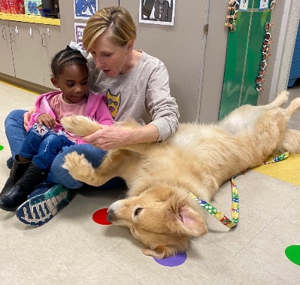
- Humane Education / Libby Listens: Humane education is an integral part of creating change for a better tomorrow for animals. Our Libby Listens program promotes responsible animal care, which directly encourages social and emotional competence. This program inspires young people and puts them on the path to be lifelong, responsible pet owners. Libby visits schools and kids read to her to become more confident readers. Our humane education coordinator teaches the children how to properly care for animals.
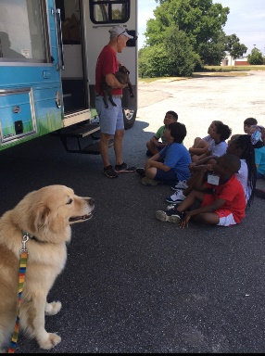
- Rescue / Transfer Program: Transferring animals saves lives! Every animal deserves a chance and our rescue and transport program ensures that as many animals as possible receive the opportunity to find forever homes. The concept behind transporting animals between shelters and rescue groups, and even between different states, is as simple as supply and demand. Many shelters are overwhelmed with certain breeds of dogs and cats for whom there is not a strong demand, leaving those animals in facilities for too long and at risk of being euthanized.
- Intake Diversion: Many people think the best thing to do is bring all animals to an already over-crowded shelter. Progressive animal sheltering recognizes that an animal shelter is not the best place for an animal to stay, so strategies are selected that focus on stabilizing communities and animal care givers; keeping pets in their existing homes; or efficiently finding new homes whenever necessary and appropriate. Keeping pets in homes and out of the shelter means there are fewer animals who need care and rehoming, saving money and time. For each individual animal, efficient movement through the shelter means less risk of illness or behavioral problems. Decreasing length of stay in shelters supports physical and behavioral health and contributes to decreases in daily population, which helps the shelter to operate within their capacity for care. Functioning beyond capacity for care is associated with poor health, creating an unhealthy cycle of crowding and disease. Having fewer dogs to care for improves the ability to provide care that truly meets the needs of the animals. Providing care that truly meets the needs of animals protects behavioral and physical well-being.
- S/N Certificate Program: Snip-It Tickets are available at Metro Animal Shelter. This certificate program targets individuals we consider in need due to financial or physical constraints. TMAS is only providing the subsidized certificates and is not involved with any medical procedure or treatment. Certificates are provided at $20 per certificate if funds are available for the program.
- Events: We hold events all over Tuscaloosa County. We hold adoption events, fundraising events, and community outreach events to let our communities know about our services.
- Happy Hour: Happy Hour is a dog walking program designed to get dogs out of the stressful environment of the shelter for daily enrichment. People considering adoption can also check a dog out for the night on Overnight Happy Hour to help determine if the pet may be a good fit for their family.
- Volunteer Program: Volunteers help us accomplish are mission. They are paramount in our everyday work. Volunteers serve in a variety of roles outlined in this manual.

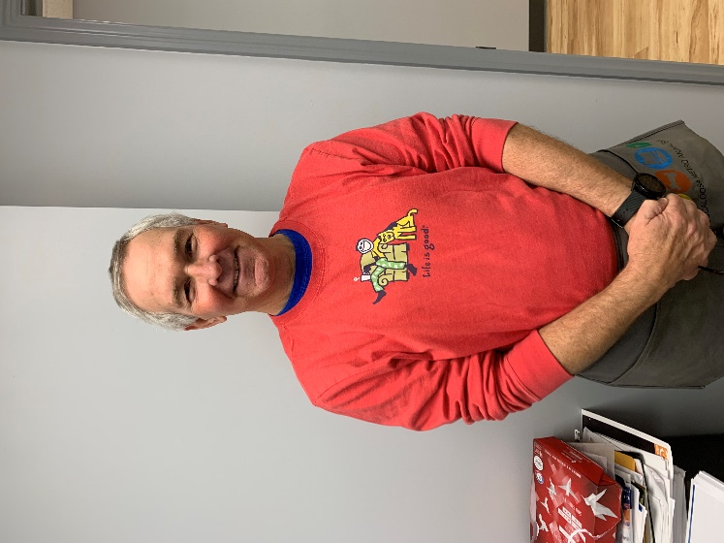
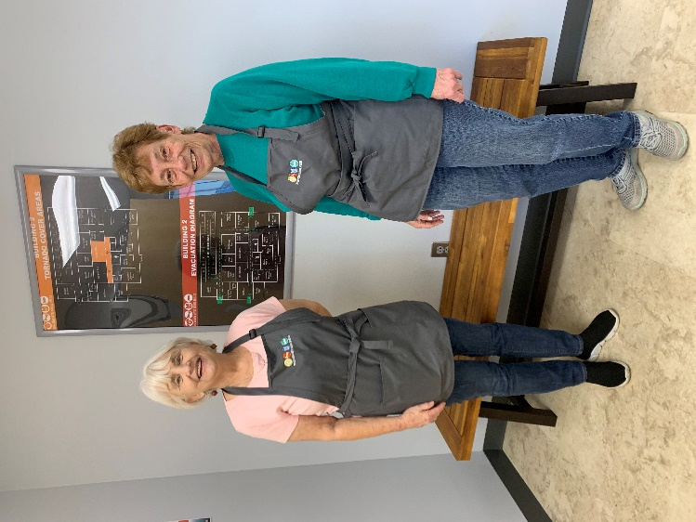
TMAS TEAM

Contact Information- Key Staff at TMAS

Executive Director
Director of TMAS Jennifer Earp jearp@metroanimalshelter.org

Shelter Operations
Office Manager Thomas Sahm tsahm@metroanimalshelter.org
Kennel Manager Tara Freeman tfreeman@metroanimalshelter.org
Health/Behavior Manager Katie Elliott kelliott@metroanimalshelter.org

Outreach Department
Volunteer Coordinator Sibyl Forsberg sforsburg@metroanimalshelter.org
Foster Coordinator Savannah Franklin sfranklin@metroanimalshelter.org
Adoption Coordinator Angela Dickey adickey@metroanimalshelter.org
Humane Education
Rescue Coordinator
Event Coordinator Becki Pate bpate@metroanimalshelter.org

Office Personnel
Office Assistant
Receptionist Catherine Moore cmoore@metroanimalshelter.org

Intake/Reclaim Team
Intake Coordinator Michelle Martin mmartin@metroanimalshelter.org
Intake Coordinator Raquel Kimball rkimball@metroanimalshelter.org

General Email Directory
Adoptions adoption@metroanimalshelter.org
Fostering foster@metroanimalshelter.org
Intake/Reclaim intake@metroanimalshelter.org
Rescue rescue@metroanimalshelter.org
Volunteer volunteer@metroanimalshelter.org
Event event@metroanimalshelter.org
Main TMAS Email tmas@metroanimalshelter.org

TMAS Mailing Address
3140 35th Street
Tuscaloosa, AL 35401
205-752-9101
Our Staff Commitment to You

The staff members at TMAS deeply appreciate your service and your dedication to help animals in our care. We want to make sure you have a wonderful and enjoyable experience. So, we strive to:
- Provide you with adequate information, training and assistance so you can be successful in your volunteer position.
- Provide you with guidance, goals and feedback.
- Respect your skills, dignity and individual needs.
- Be open-minded and receptive to your comments and suggestions.
- Treat you as a valued team member, equal to our staff.
The TMAS volunteer program is led by a volunteer coordinator and a team of individual program coordinators and managers. These staff members are responsible for the maintenance of all volunteer programs within their purview.
Depending on the program/department, staff responsibilities may include but are not limited to:
- Recruiting volunteers for specific organization needs and skill sets.
- Providing all new volunteers with orientation and training.
- Assisting with scheduling of volunteers for specific events or programs.
- Maintaining the safety and confidentiality of volunteers’ records and personal information.
- Providing appropriate and regular recognition for active volunteers.
- Providing updated information about TMAS activities and opportunities.
- Processing requests from TMAS staff for volunteer assistance, including volunteers for events, initiatives, or special projects.
- Providing written documentation of volunteer time or activities when requested.

The TMAS Volunteer Experience

When you volunteer with TMAS, you are giving the animals one of the greatest gifts of all — your time. Whether you are spending one-on-one time with the animals, helping at events or assisting in some other way, you are helping the animals to feel loved. For that, everyone here at TMAS is incredibly grateful, especially the animals. Volunteering at an animal shelter can, at times, be emotionally and physically challenging. Remember to focus on the big picture. The animals on counting on us! We wish you an enjoyable, safe, fulfilling and rewarding volunteer experience! To learn more about volunteering with TMAS and to ensure an even better volunteer experience, please take a few minutes to read this guide.

What can you do for TMAS?

You can participate in a variety of volunteer activities at TMAS or offsite at one of our events. Whether you prefer one on one time with animals, assisting the public, helping our program coordinators with different programs, general office assistance, or working at events, there is a spot for you! On the following pages, you will see a variety of job descriptions. Look through them and talk to the Volunteer Coordinator if you have any questions and to help determine where you are needed most based on your interests and abilities.
Volunteer Benefits
Being an animal shelter volunteer is good for your emotional, physical, and mental health. It is scientifically proven that spending time with animals helps lower your stress levels and blood pressure. It will also keep you active, especially if you prefer to walk dogs. You will meet great people, learn new skills, improve your health and mood, become a part of your community, and be a shining light for a disheartened animal.

You will receive formal and informal appreciation. Specific highlights from the shelter include buttons or pins once you reach specific amounts of volunteer hours, recognition on social media and possible mention on our website, and yearly volunteer appreciation celebrations.

Age Requirements

We allow anyone 5 years old and up to volunteer with us. Children ages 5 to 15 must be accompanied by a parent or legal guardian. For the protection of children and the animals in our care, children 4 and younger may not volunteer or accompany parents or guardians volunteering with other children. Children will be assigned to age appropriate activities. Volunteer activities available to minor volunteers are at the discretion of TMAS. A parent or legal guardian must sign a volunteer waiver for anyone under the age of 18.

Open House

Anyone interested in volunteering is asked to attend an Open House. The purpose of our Open House is to let people know about our organization and what it is like to be a volunteer. We hold Open House at the shelter the second and last Saturday of each month at 3 pm.

Process to Volunteer at TMAS

- Register online at https://tmas.givepulse.com. Click on “Become a Member”. Fill out the profile information to complete the initial registration as a volunteer. After creating your account, you can quickly log into your account via https://tmas.givepulse.com.
- You must watch the volunteer orientation video. You can find this online at https://www.metroanimalshelter.org/volunteer. You can also find it in your TMAS GivePulse account. Once you watch it, you must answer a few questions to verify you did.
- Complete all forms, waivers, and the code of conduct as required by your volunteer assignments before performing any volunteer work. Keep all your profile information up to date.
- Sign up for Volunteer Activities. Assignments for a variety of volunteer activities are posted on the volunteer web page and you can schedule yourself for various activities and shifts that fit your interests and schedule.
- Our Volunteer Coordinator will reach out to you the afternoon before your scheduled shift to confirm you are coming. Upon arrival you will grab your volunteer apron (gray) and clock in. All volunteers will be required to wear an apron while volunteering. You will be paired with a mentor in the area of which you chose to volunteer.

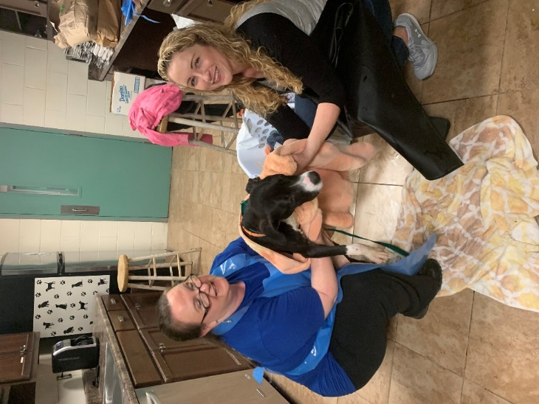
Scheduling Your Service

You Must Be on the Schedule to Participate

Volunteer accountability is vital to TMAS overall success. To ensure coverage of volunteer activities, all volunteers must schedule their time on Better Impact at least 24 hours in advance. Each day, our receptionist will have a list of volunteers who are scheduled to be on the premises of TMAS and will allow only those on the schedule to volunteer.

Daily Time on Premises

All volunteers are only allowed in the building during office hours. Volunteers can arrive at 9am each business day and must leave by 6pm each business day. Exceptions to this will only be made if there is a scheduled event not within this timeframe.

Log your Service Hours

You will log in on arrival to volunteer and log out upon leaving. It is up to the volunteer to keep up with his/her own hours. In the event documentation is needed of the hours performed, our Volunteer Coordinator will prepare the documentation.

Missing Shifts / Your Commitment

Your support matters. The animals and the TMAS team are counting on you. Missing assigned shifts leaves spots available that could have otherwise been staffed by other volunteers. You can change your volunteer assignment online 24 hours prior to the assignment date and time if you cannot fulfill your previously scheduled activity. We understand things happen. If you are unable to change your scheduled shift due to an emergency or unplanned event, please contact our volunteer coordinator. Missing 3 or more assigned shifts will result in your removal from the TMAS volunteer program.
When you serve as a TMAS volunteer, we ask the following of you:

- Have regular access to the internet and a private email address.
- Respond to direct emails from volunteer staff in a timely manner.
- Use the TMAS login system (Better Impact) to schedule volunteer shifts and log volunteer hours.
- Show up on time.
- Keep your volunteer record updated with your current email address, phone number, and emergency contact.
- Stay within the parameters of your volunteer position(s) and assignment(s)
- Grant TMAS rights to all photographic images, video, and audio recordings made for TMAS or on our property of any volunteer.
- Follow the dress code outlined in this handbook when representing TMAS onsite and offsite.
Code of Conduct

Respectful Behavior

As a member of the TMAS team, you are a representative of TMAS’s brand and image and are expected to conduct yourself in a professional manner. You must be respectful and courteous in your interactions with the public and with staff. Disrespectful or unprofessional behavior, sexual harassment, threats, disparaging remarks, discrimination, or vulgar language will not be tolerated, and you may be asked to cease your volunteer work as a result of such conduct. This code of conduct applies to online and/or written material, as well as personal interactions with staff, other volunteers, and members of the public. Commit to providing excellent customer service to our visitors, staff, and fellow volunteers.

Non TMAS Guests / Pets
It is not appropriate to bring children, friends, or anyone not registered as a TMAS volunteer to the facility while you are performing volunteer activities. Personal pets are also not allowed. Volunteers with unapproved guests or pets will be asked to leave.

Privacy Policy and Conveying Correct Information

Information pertaining to TMAS records or specific cases are strictly confidential and may not be discussed with others. Please refrain from offering the public information on fees or policies unless you are sure you have current, accurate information. When in doubt, always refer the person to TMAS staff. Volunteers are not to disclose any confidential information (contact, personal information, financial, etc.) of shelter customers or staff members. Only TMAS approved signage and messaging are allowed on premises and at TMAS events. Do not write notes or messages on kennel cards, on paper signs or affix any other signs or messages without prior approval from TMAS management.

Dress Code

Be prepared to get dirty. When working with animals, you are advised to cover as much skin as possible to avoid scratches, exposure to zoonotic communicable illness, ringworm, mange, fleas, and/or ticks. As a TMAS volunteer, you are required to wear the following during each activity at TMAS:

- Closed toe, slip resistant shoes. No flip flops or sandals.
- T-shirt. No tank tops or halter tops
- TMAS apron which you will get and put on at arrival.
- No skirts or dresses. Pants recommended.
- Jewelry not reommended.

Parking

Volunteers should park in spots closest to the road. You may enter from the main lobby. Do not park in grass or in in drive area. Do not block access gate.

Smoking

Smoking is prohibited in the building and on facility grounds. While working at off-site events as a TMAS volunteer, you may not smoke except when out of public view and if allowed on that property.

Drugs and Alcohol

Under no circumstances shall a volunteer work at our facility or offsite event under the influence of drugs or alcohol. If suspected of being under the influence of drugs and/or alcohol, you will be asked to leave immediately and will be subject to termination from the TMAS Volunteer Program.

Cell Phones

While you are here, we want you to keep your focus on the animals in your care and the customers in need of assistance. TMAS strictly prohibits the use of cell phones and mobile devices that create unsafe situations. We suggest you keep your phones in your car. Cell phone use while handling animals is strictly prohibited. Volunteers also may not use their phones while interacting with TMAS customers. If it is necessary for you to have your cell phone with you while volunteering, set the ringer to vibrate or silent, and use your cell phone in non-working areas only and off the clock. Ear buds, headsets, and headphones shall not be used at any time while volunteering with TMAS. These create unsafe situations and make it difficult for you to hear pages. Use of any device while working with the public or animals will result in corrective action.

Animal Care

It is expected that TMAS volunteers treat all animals in the shelter’s care with compassion and gentleness. Ask for assistance from TMAS staff when needed, and use caution always. Notify TMAS staff of any observations or information you feel may need to be noted for an animal. Volunteers are not to diagnose medical cases, remove sick animals from cages, or take any animals from the shelter without proper documentation (Foster or Happy Hour).

Injuries

You are responsible for your own health and welfare, so be sure to mind all signs and safety precautions. If you are injured in any way while at TMAS, you must notify the Volunteer Coordinator or Manager on duty immediately.

Complaints

Your point of contact regarding volunteering or shelter activities is the Volunteer Coordinator. Bring your concerns or questions to this person first. If you have a complaint regarding a staff member, immediately reach out to the Volunteer Coordinator. If you are not satisfied with the resolution, you may take your complaint to the manager on duty. We want to resolve issues so we can all work effectively as a team.

Volunteer Performance Support / Causes of Release from Volunteer Service

Our goal is to make sure all our volunteers have wonderful, rewarding experiences with TMAS, while providing the best care possible to the animals. Some volunteer activities offer volunteer training and performance feedback. Performance feedback gives TMAS staff a chance to meet with volunteers one-on-one to review the position description, discuss what is going well, and identify goals and areas for improvement.

If, as a volunteer, you have not acted in TMAS’s interests, it may be necessary to end the volunteer relationship. Volunteer management staff may end your volunteer relationship at will. When the relationship between TMAS and a volunteer is terminated, all TMAS property, if any has been issued, must be returned to the volunteer team contact immediately. Potential causes for release from volunteer service include, but are not limited to:

- Failure to adhere to the standards of conduct and customer service.
- Breaking of confidentiality.
- Failure to adhere to policies or follow procedures.
- Inactivity.
- Inappropriate drug or alcohol use.
- Excessive “no-show” for volunteer shifts (3 or more).
- Not fulfilling the duties of the volunteer position.
- Theft.
- Violence or implication of violence.
- Causing injury, distress, death or the inappropriate handling of an animal.
- Horseplay or behavior that endangers other persons or property.
- Deliberate or careless damage of TMAS property.
- Disregarding safety or security policies.
- Solicitation or accepting compensation from other volunteers, clients or others, (i.e. monetary “tips”, “gifts”, “gratuities”, products or services).
- Fighting or using obscene, abusive, or threatening language or gestures.
- Unauthorized possession of weapons.
- The commission of a crime or engaging in criminal conduct while on TMAS property, or while conducting TMAS business offsite.
Volunteer Term

Both you and TMAS are free at any time, with or without notice or cause, to end the volunteer relationship. Dismissed volunteers are not permitted entry to TMAS beyond the general public interaction offsite.

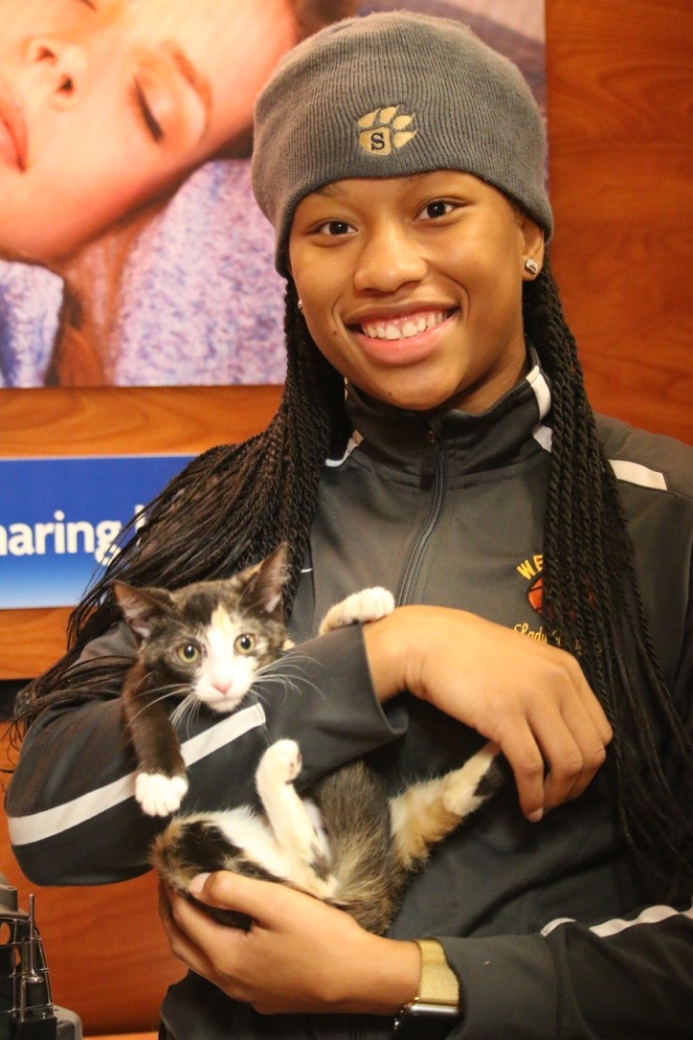

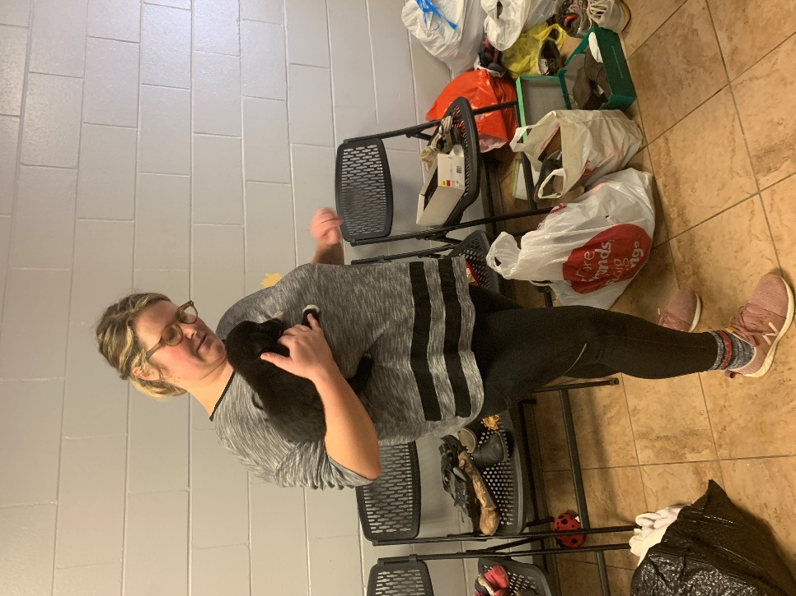

Working with and Representing TMAS

Social Media

Online communication tools such as blogs and social media networks (e.g., Facebook, Twitter and Instagram) are becoming the go-to channels for people who are interested in keeping up with TMAS and our many efforts. For that reason, and because your behavior as a volunteer reflects on TMAS, please use good judgment whenever you contribute to TMAS’s social media pages. We encourage volunteers to join online conversations and spread the word about TMAS and the animals, but you should never speak as an official representative of TMAS. When you are engaging with others via social media on behalf of TMAS, please keep in mind the following:

- Be transparent: Identify yourself as a volunteer of TMAS.
- Be accurate: Make sure you check your facts with a staff member who is involved with the issue before posting. Take every precaution to gather the most current information available. Be the first to acknowledge and correct your own mistakes.
- Provide resources: Link back to our website whenever you can so that people can see where your information is coming from.
- Be considerate: Please do not use profanity, derogatory language or personal attacks, or engage in any other inappropriate conduct. Be professional: Do not allow legitimate online explanation of a position or debate to devolve into personal attacks, fights or flame wars that would reflect poorly on you or TMAS. If you have any doubts about the appropriateness of your involvement in an online discussion, please disengage or do not get involved in the first place. Pass along the link to your volunteer coordinator.
- Protect sensitive information: Protect TMAS’s confidential information as well as the personal information of others. Get permission to use copyrighted content such as photos or videos, or to cite or reference our supporters, partners or suppliers. Do not disclose or use any confidential or business information about TMAS, such as member or donor information. Do not disclose personal information about co-workers, volunteers or former employees.
- Please follow guidelines: If you are a member of a Facebook Group (volunteer, foster, etc.) run by TMAS, please follow all guidelines created by the administrators of the page. Failure to follow guidelines may result in removal of the group.

You are encouraged and welcome to use your own social media platforms to help promote adoptable animals, events, volunteer opportunities, advocacy, outreach and more. However, TMAS volunteers are prohibited from starting any new social media properties that represent the organization. If you have any questions about this, please contact your volunteer coordinator.

You are strongly encouraged to follow all our social media accounts. They are listed below.

TMAS Social Media Accounts

Facebook: @Tuscaloosa Metro Animal Shelter
Twitter: @MetroAnimalShel
Snapchat: @MetroAnimalShel
Instagram: metroanimalshelter
Youtube: Tuscaloosa Metro Animal Shelter

Media Contact and Public Commentary

Volunteers are prohibited from speaking on behalf of TMAS to any representative of the media. All media questions are handled by our Director. Questions should be forwarded to tmas@metroanimalshelter.org

Understanding Euthanasia

Euthanasia is always our last option and we always strive to place an animal into a good home if available. We hope that through spay/neuter efforts and humane education, there will be fewer cats and dogs needing homes in the future. As a volunteer, you may be exposed to animals facing euthanasia, even though you never have to witness it. TMAS uses a humane sodium pentobarbital solution injected intravenously when there is a case of euthanasia that must be performed. There are animals who come in severely injured, have severe behavior issues that cause safety concerns for people, there are unweaned puppies/kittens who are not thriving, or animals with extreme illness who may need euthanasia.

Disease Control

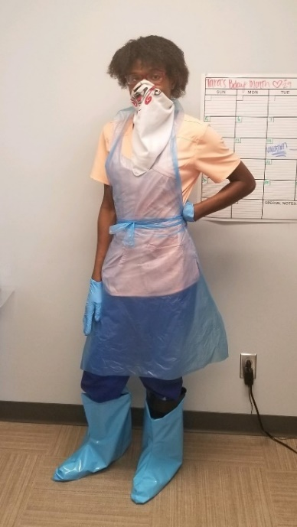
As a volunteer at TMAS, you must wash your hands frequently, as well as clean all animal handling equipment thoroughly to prevent the spread of disease at the shelter. Disease Control protocols are part of your training with mentors when you begin your service. Wearing appropriate Personal Protection Equipment when applicable will help decrease the spread of disease. If you are bitten or scratched, you must report the incident to the Office Manager. Be sure to have the correct identity of the animal ready. You are responsible for your own personal health and are advised to seek medical treatment from your doctor.

Community Groups & Events

TMAS schedules and plans activities and events onsite as well as offsite for adoptions, awareness, and other outreach initiatives as far in advance as possible. As such, TMAS has established protocols, procedures, branding standards, and assigned resources. All activities and events, either on premises or as represented as TMAS in the public, must be coordinated and approved by TMAS management at least 45 days in advance.

Volunteer Groups, Organizations, or Clubs

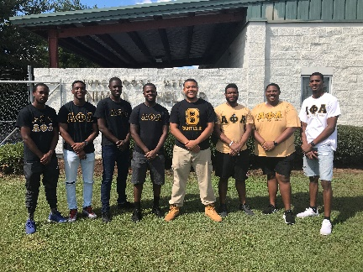
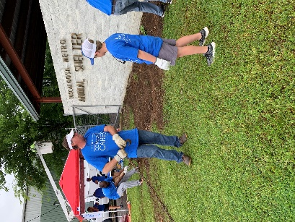
Any group or organization wishing to hold an event or group volunteer project must contact the Volunteer Coordinator in advance to make such arrangements. Groups will not be allowed to assemble at events or onsite and promote their business, cause, or messaging without prior approval from TMAS management.

Volunteers Wishing to Help at Events

If coming to the shelter is too much for you and you are looking to help in another way, you can help just at events. The volunteer signup process is the same. Log in to the volunteer portal to volunteer at scheduled event.
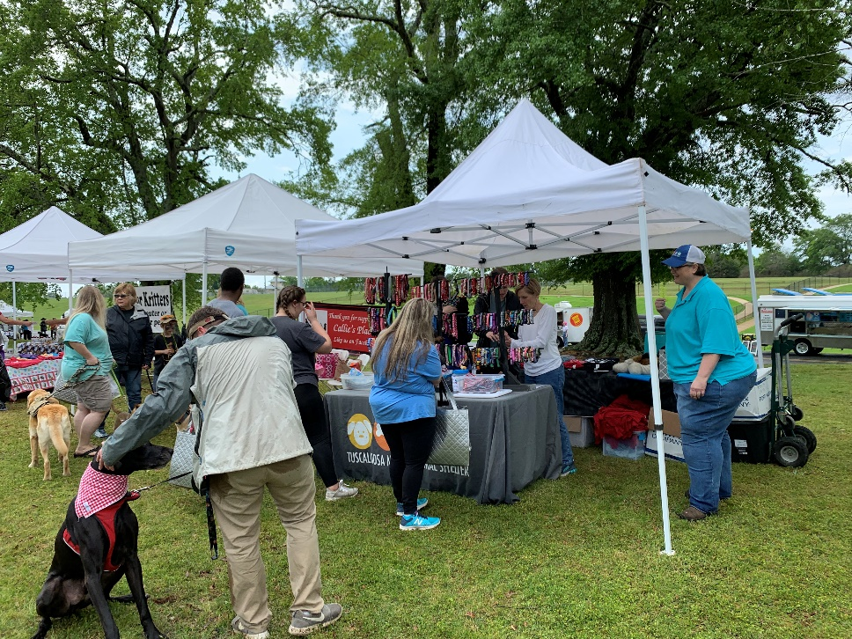

Volunteer Training

Pairing with Mentors / Staff in Specific Areas

All volunteers will be paired with staff or volunteer mentors for training in a designated area. Videos will also be available in the volunteer portal to help along the way.

Playgroups

We believe in the Dogs Playing for Life motto of “every dog, every day”. This means every dog deserves playtime every day. While volunteers can walk leashed dogs daily, a playgroup handler can attend to many dogs allowing for enrichment and positively affect their quality of time spend in the shelter, leading to animals being less stressed and more adoptable. As stated on the DPFL website, “playgroups provide an outlet for dogs to burn off some excess physical energy, socialize with other dogs, and go back to their kennel tired and satiated!” Volunteers wishing to help with Playgroup activities must have 20 hours of service Dog Walking before playgroup training takes place. We need consistent help with Playgroup activity.

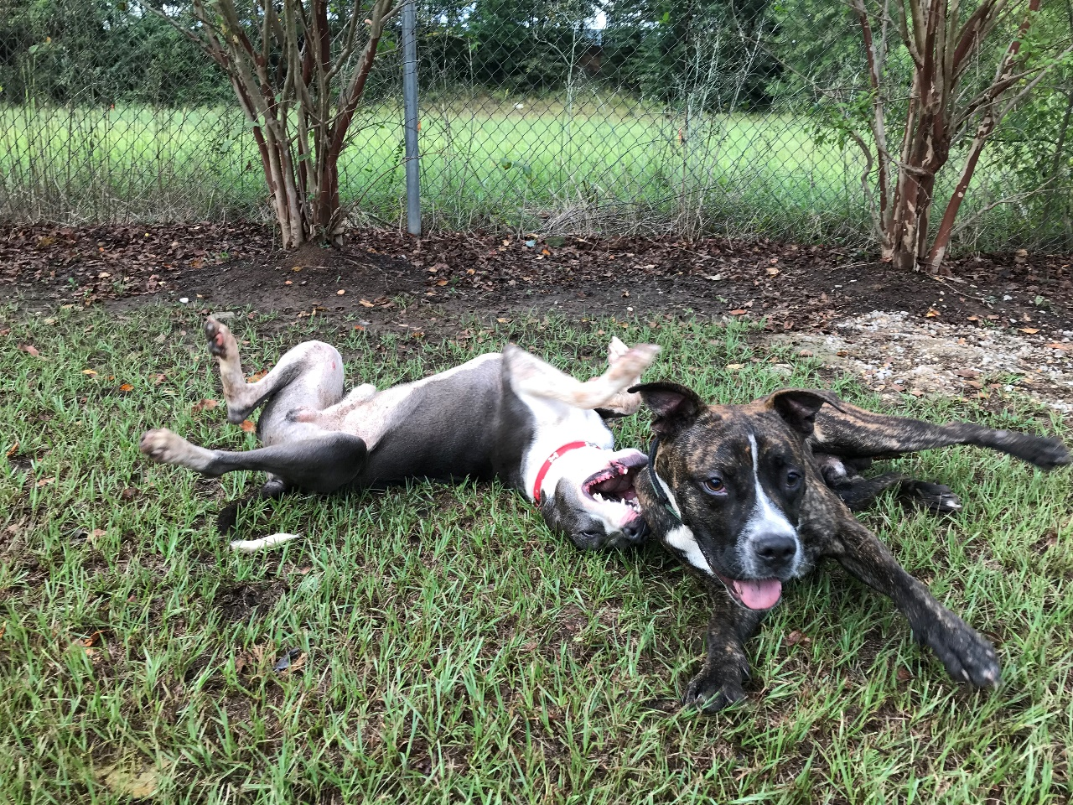

Volunteer Jobs

TMAS Ambassador

Key Responsibilities / Requirements

This is a client and staff support volunteer position. This position is charged with helping provide quality and compassionate assistance to all incoming members of the public which includes greeting them as they enter and locating their respective service or department. This will include, but is not limited to:
- Showing customers to adoptable animals.
- Helping facilitate customers in meeting with an adoption counselor, foster, rescue, volunteer coordinator, or intake coordinator.
- Assisting receptionist.

Ambassadors will attend training both as a TMAS volunteer and as an Ambassador. In these trainings, the Ambassador will become familiar with the overall operation of the shelter as well as its layout. Once trained, the Ambassador will shadow an experienced Ambassador to become familiar with the position.
Training and Orientation to Position

The orientation will include the following:
- Discussion of overall duties.
- TMAS personnel to be familiar with (Director, Managers, Adoption Counselors, Foster Coordinator, Rescue Coordinator, Volunteer Coordinator, Humane Education Coordinator, Intake staff, and Animal Care Technicians).
- Areas/Programs to be familiar with (Adoptions, Foster, Volunteer, Rescue, Lost and Found, Animal Reclaim, and Happy Hour).
- Tour of facility.
- Discuss setting up a routine schedule.

Reports to

Volunteer Coordinator

Hours

Flexible hours during office hours. Ambassador will work with Volunteer Coordinator for scheduling.
Adoption Counselor

Key Responsibilities / Requirements

Adoption Counselors aid those looking to find that special pet. Adoption Counselors will:

- Provide excellent personal interaction with potential adopters so they have a wonder experience.
- Help adopters find the animal they are looking for by talking with them about their lifestyle and home environment.
- Assist with the movement of animals in and out of their cages so adopters can interact with the animals.
- Direct adopters through the adoption process so they can complete it successfully.
- Must be 18 years or older.
- Must complete 10 hours of Dog Walker program and 10 hours of Cat Cuddler program to learn basic protocols regarding animal care. This is essential in order to help the public.

Training and Orientation of the Position

You will work directly with a staff adoption counselor to learn details needed about our Adoption Program so you can efficiently help potential adopters.

Reports to

Adoption Coordinator
Volunteer Coordinator

Hours

Flexible hours during office hours.

Animal Care Assistant

Key Responsibilities / Requirements

Animal Care Assistant’s help with a variety of tasks including bathing or brushing dogs, cleaning cages, enrichment, or bottle feeding.

- Will be asked to communicate with the public daily in a professional manner.
- Must be able to learn basic veterinary concepts or protocols regarding the animals’ care.
- Ability to follow instructions.
- Must be able to bend and kneel repeatedly.
- Must be able to work in potentially extreme environmental temperatures.
- Must have good range of motion, have good vision, and possess good hand-eye coordination.
- Provide gentle care to the animals you are working with.

Training and Orientation of the Position

You will work directly with a mentor (staff or experienced volunteer) to learn details needed to help as an animal care assistant.

Reports to

Volunteer Coordinator

Hours

Flexible hours during office hours.

Cat Cuddler

Key Responsibilities / Requirements

Cat Cuddlers specifically work with cats. Duties may include playing with cats with toys, petting, providing individualized attention to those who need it.

- Need to be able to identify fear, anxiety, and stress in cats.
- Will be asked to communicate with the public daily in a professional manner.
- Must be able to learn basic veterinary concepts or protocols regarding the animals’ care.
- Ability to follow instructions.
- Must be able to bend and kneel repeatedly.
- Must have good range of motion, have good vision, and possess good hand-eye coordination.
- Provide gentle care to the animals you are working with.

Training and Orientation of the Position

You will work directly with a mentor (staff or experienced volunteer) to learn details needed to help as a Cat Cuddler.

Reports to

Volunteer Coordinator

Hours

Flexible hours during office hours.

Dog Walker

Key Responsibilities / Requirements

Dog walkers work with dogs. Duties may include walking dogs around the building or in the play yard, playing with toys, petting, providing individualized attention to those who need it.

- Being comfortable with all types of dogs and sizes is a necessity.
- Report on the behavior of dogs.
- Recognize fear, anxiety, and stress in dogs.
- Will be asked to communicate with the public daily in a professional manner.
- Must be able to learn basic veterinary concepts or protocols regarding the animals’ care.
- Ability to follow instructions.
- Must be able to bend and kneel repeatedly.
- Must have good range of motion, have good vision, and possess good hand-eye coordination.
- Provide gentle care to the animals you are working with.

Training and Orientation of the Position

You will work directly with a mentor (staff or experienced volunteer) to learn details needed to help as a dog walker.

Reports to

Volunteer Coordinator

Hours

Flexible hours during office hours.

Happy Hour Participant

Key Responsibilities / Requirements

Happy Hour is meant for people to provide exercise for a dog off-site. You can take the animal to your house, to the lake, or for a jog. The only place you cannot go is to a dog park or where there may be lots of animals. You are a good source of information for anyone looking to adopt. Learning information about dogs outside of the shelter is a great way to help ensure the dog’s get adopted faster. Happy Hour is also a good thing to do if you are looking to adopt.

- Being comfortable with all types of dogs and sizes is a necessity.
- Report on the behavior of dogs.
- Recognize fear, anxiety, and stress in dogs.
- Will be asked to communicate with the public daily in a professional manner.
- Must be able to learn basic veterinary concepts or protocols regarding the animals’ care.
- Ability to follow instructions.
- Must have good range of motion, have good vision, and possess good hand-eye coordination.
- Provide gentle care to the dog while in your care.

Training and Orientation of the Position

You must watch the video online in your volunteer portal before participating in Happy Hour. A quiz will accompany the video to know you watched. The Happy Hour program assistant will provide information to you again once you arrive.

Reports to

Volunteer Coordinator

Hours

Between these hours

Monday: 10a- 5p
Tuesday: 10a-5p
Thursday: 10a-5p
Friday: 10a-5p
Saturday: 10a-5p

Happy Hour Program Assistant

Key Responsibilities / Requirements

Happy Hour is meant for people to provide exercise for a dog off-site. Your responsibility would include assisting those looking to participate in Happy Hour, provide participant with appropriate information and remind them of protocols, and get the dog out of the cage for participant. You will also put the dogs up upon their return.

- Know all protocols associated with Happy Hour
- Being comfortable with all types of dogs and sizes is a necessity.
- Report on the behavior of dogs.
- Recognize fear, anxiety, and stress in dogs.
- Will be asked to communicate with the public daily in a professional manner.
- Must be able to learn basic veterinary concepts or protocols regarding the animals’ care.
- Ability to follow instructions.
- Must have good range of motion, have good vision, and possess good hand-eye coordination.
- Provide gentle care to the dog while in your care.

Training and Orientation of the Position

You must watch the video online in your volunteer portal before participating in Happy Hour. A quiz will accompany the video to know you watched. It explains the “how-to”. A mentor will also walk you through the process upon arriving your first day.

Reports to

Volunteer Coordinator

Hours

Between these hours

Monday: 10a- 4pm
Tuesday: 10a-4p
Wednesday: 10a-4p
Thursday: 10a-4p
Friday: 10a-4p
Saturday: 10a-4p

Foster Program Assistant

Key Responsibilities / Requirements

Our Foster Program is how we can save so many animals. It is vital to our operations. Animals go into temporary housing with loving foster parents while we actively try to find permanent placement. A Foster Program Assistant helps our Foster Coordinator with daily phone calls to foster homes, paperwork entry, and general assistance with the foster process.

- Learn all protocols associated with our Foster Process
- Being comfortable with all types of dogs/cats and sizes are a necessity.
- Assist foster parents with their concerns and schedule appointments when needed.
- Must be able to learn basic veterinary concepts or protocols regarding the animals’ care.
- Will be asked to communicate with the public daily in a professional manner.
- Ability to follow instructions.
- Must have good range of motion, have good vision, and possess good hand-eye coordination.
- Provide gentle care to the dog while in your care.
- Must be 18 years or older.
- Must complete 10 hours of Dog Walking and 10 hours of Cat Cuddlers to learn about basic protocols regarding animal care. This is essential in order to help the public.

Training and Orientation of the Position

You will work with our Foster Coordinator or another trained mentor.

Reports to

Foster Coordinator
Volunteer Coordinator

Hours

Between our regular business hours. Flexible.
Maintenance Team

Key Responsibilities / Requirements

The maintenance of our facility and grounds is paramount in having people visit the shelter. We want people to enjoy coming to the shelter. We must keep it as clean as possible. Some duties and requirements include, but are not limited to:

- Dish washing (following our protocols).
- Sweeping
- Laundry
- Cleaning cages
- Washing windows
- Cleaning vehicles
- Lawn maintenance
- Must follow all instructions and protocols.
- Must have good range of motion, have good vision, and possess good hand-eye coordination.

Training and Orientation of the Position

You will work with our Kennel Manager or trained mentor.

Reports to

Kennel Manager
Volunteer Coordinator

Hours

Between our regular business hours. Flexible.
Petsmart Team

Key Responsibilities / Requirements

We send cats to Petsmart to be adopted. Petmart has cages in-store. We need volunteers to help us go by there once a day to help with the cleaning and feeding of the cats. As a Petsmart volunteer, you must:

- Learn and carry out all protocols associated with our Foster Process
- Be comfortable with cats.
- Must be able to learn basic veterinary concepts or protocols regarding the animals’ care.
- Must have good range of motion, have good vision, and possess good hand-eye coordination.

Training and Orientation of the Position

You will work with a trained staff member or mentor.

Reports to

Volunteer Coordinator

Hours

In the morning between the hours of 9am-11am. We must get them cleaned and fed as soon as Petsmart opens.
Volunteer Coordinator Assistant

Key Responsibilities / Requirements

Volunteers are our lifeline. We cannot do what we do without them. After completing 40 hours of service, you can become a volunteer assistant. It is important to learn aspects of all the shelter does to be able to properly assist other volunteers coming to the shelter. You must:

- Learn all protocols associated with our facility and programs.
- Be comfortable with all types of dogs/cats and sizes.
- Assist any volunteer or potential volunteer with job functions or how to sign up.
- Must be able to learn basic veterinary concepts or protocols regarding the animals’ care.
- Will be asked to communicate with the public daily in a professional manner.
- Ability to follow instructions.
- Must have good range of motion, have good vision, and possess good hand-eye coordination.
- Must be 18 years or older.
- Must complete 40 hours of service prior to being a volunteer.

Training and Orientation of the Position

You will work with our Volunteer Coordinator or another trained mentor.

Reports to

Volunteer Coordinator

Hours

Between our regular business hours. Flexible.

Playgroup Volunteer

Key Responsibilities / Requirements

We believe in the Dogs Playing for Life motto of “every dog, every day”. This means every dog deserves playtime every day. While volunteers can walk leased dogs daily, a playgroup handler can attend to many dogs allowing for enrichment and positively affect their quality of time spend in the shelter, leading to animals being less stressed and more adoptable. As stated on the DPFL website, “playgroups provide an outlet for dogs to burn off some excess physical energy, socialize with other dogs, and go back to their kennel tired and satiated!” Volunteers wishing to help with Playgroup activities must have 20 hours of service Dog Walking before playgroup training takes place. We need consistent help with Playgroup activity.

- Learn all protocols associated with dog handling.
- Must learn to recognize fear, stress, and anxiety.
- Being comfortable with all types of dogs and sizes are a necessity.
- Ability to follow instructions.
- Must have good range of motion, have good vision, and possess good hand-eye coordination.
- Must be 18 years or older.
- Must complete 20 hours of Dog Walking before playgroup training takes place.

Training and Orientation of the Position

You will work with our Behavior team and other trained mentors. We will give you information to review that comes directly from the Dogs Playing for Life manual.

Reports to

Volunteer Coordinator

Hours

Between our regular business hours. Flexible.

Videography / Photography

Key Responsibilities / Requirements

Videos and photos are a great way to showcase our animals. If you dabble in either, we would love for you to help us! Whether making training videos or new pictures for animals in our care, we could use your expertise!

- All you need is the skill to take great photos and video. Editing is also helpful.
- Once these are taken, you will send them to our shelter’s main email. tmas@metroanimalshelter.org

Training and Orientation of the Position

You will work with our Volunteer Coordinator and other volunteers to take pictures and videos.

Reports to

Volunteer Coordinator

Hours

Between our regular business hours. Flexible.

Events

Key Responsibilities / Requirements

We do events all over town. Volunteers who help at events must review videos in their volunteer portal before participating at an event. In the video, you will learn proper animal handling and dog walking, general rules and protocols for walking at events. Light cleaning of cages in our mobile transport and adoption vehicle are required when helping at events.

- Must be comfortable around dogs and cats of all sizes and types.
- Must follow all procedures and protocols.
- Must be polite and courteous to all clients and potential clients.
- Ages 16 and up can help at events.

Training and Orientation of the Position

You will work with our Volunteer Coordinator and Event personnel.

Reports to

Volunteer Coordinator

Hours

Events take place at different times of the day.

Transport Driver or Event Driver

Key Responsibilities / Requirements

Animals need our help getting to other organizations who help us find forever homes for our animals. We need your help getting them there. We have a Freightliner that does not require a CDL license. You must:

- Be at least 19 years or older.
- Participate in 2 transports before being allowed to drive the Freightliner. Once you participate in 2, you can drive the truck to an event or transport.
- Must have a clean driver’s license and be approved by our insurance company.

Training and Orientation of the Position

You will work with our Volunteer Coordinator and Transport Coordinator.

Reports to

Volunteer Coordinator

Hours

Hours vary based upon need. Must be flexible.

Community Support

Donations

We are a 501c (3) organizations and rely heavily on donations, both monetary and in-kind donations. Donations may be brought to the front desk at 3140 35th St., Tuscaloosa, AL 35401, at any time during TMAS public hours. You may also bring donations with you when you are scheduled to volunteer. All supplies donated must be unexpired and unopened to be usable. TMAS is always in need of the following items (immediate needs are in red):

  - Flea Shampoo
  - Towels and small hand towels
  - Newspapers
  - Kong toys and other sturdy, washable dog toys
  - Wand-type, interactive cat toys
  - Washable, plastic, ball-type cat toys
  - Natural rawhide chews
  - HE (high efficiency) liquid laundry detergent
  - Dryer sheets
  - Tough, empty plastic bottles such as Gatorade or bleach bottles
  - Unopened, unexpired peanut butter, spray cheese, or hot dogs (these are for training purposes)
  - Air freshener
  - Paper bags
  - Small Cardboard boxes
  - Fabric softener
  - Rubbing alcohol
  - Hydrogen peroxide
  - Office Supplies (Copy paper, construction paper, markers, paper clips, note cards)
  - Bleach
  - Clorox Wipes
  - Plastic Storage Bins
  - Hair animal clippers
  - Dry Dog, Cat, Kitten, or Puppy Food
  - Kitten and puppy nursing bottles
  - Kitten Milk Replacer (KMR)
  - Puppy Milk Replacer (Esbilac)
  - Canned cat, dog, puppy, and kitten food
  - Natural dog and cat treats
  - Flea and tick prevention
  - Litter and litter boxes
  - Leashes and collars
  - Nail grooming equipment
  - Dog & Cat Brushes
  - Pooper-scoopers
  - Toilet paper
  - Paper towels
  - Blankets
  - Dog and cat beds (please, no sheets, house pillows, or thick comforters)
Donations Continued

You can make a regular monetary donation to support programs or other fundraisers, donate in memory of or in honor of someone, or set up planned giving (wills, bequests).

Fundraisers

People can do fundraisers on our behalf. Start a fundraiser directly from our website. Fundraise on behalf of an animal, in honor of your birthday, or for any reason you choose. Go to https://www.metroanimalshelter.org/fundraisers

Sponsorships

Donors can sponsor animal adoption fees, individual cages, play yards, events, etc. Any amount can be placed to sponsor partial adoption fees. If interested in a sponsorship donation, visit our website https://www.metroanimalshelter.org/donate.

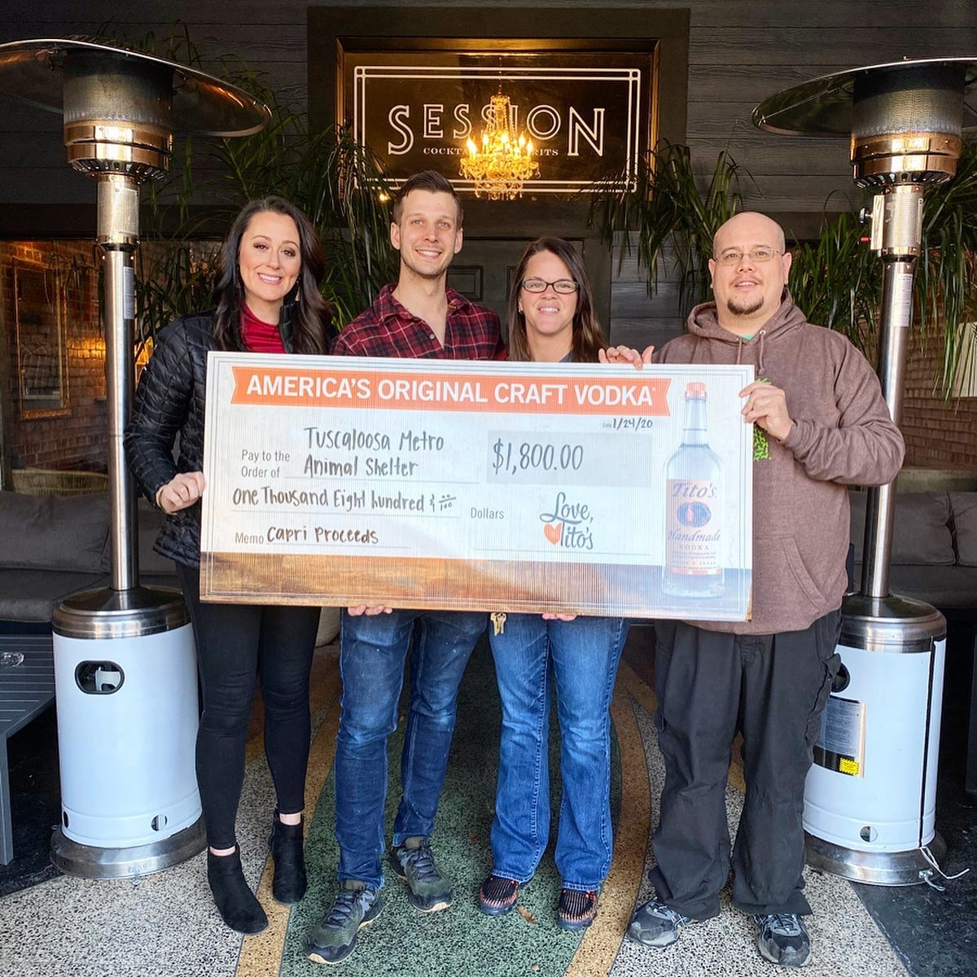
General Information

Requests for Animal Help

As a TMAS representative, you may be asked by people in your community for help with specific animal situations. Here are some ways to handle these requests:

- To help people find solutions to common problems, direct them to our website www.metroanimalshelter.org. Local rescue groups, animal control numbers, assistance with feral cats, wildlife assistance, cruelty or neglect, etc., will be listed.
- If the person has witnessed animal abuse or neglect, tell him or her to report it to local authorities — the local police or animal control departments. Encourage people to report the abuse not only to help the animal in distress, but also to make local officials aware of the severity of the problem. If you anticipate that the situation will become very public or you are contacted by the media or a high-ranking official, please notify your TMAS contact to get further instructions.

Conflicts of Interest

As a volunteer for TMAS, you should avoid any outside activity that could negatively affect the independence and objectivity of your judgment, or interfere with the timely and effective performance of your duties and responsibilities, or that could discredit TMAS or conflict or appear to conflict with TMAS’s best interests. The success of TMAS rests on its reputation and the goodwill of its many supporters. Unless expressly authorized, no outside activity should involve the use of TMAS assets, funds, materials, facilities, time or the services of other TMAS volunteers and employees. Violations of this policy may result in release from volunteer service with TMAS. If you are asked to take part in an activity that conflicts with the vision and philosophies of TMAS, or if a potential or actual conflict of interest arises, please contact the volunteer coordinator.

Harassment Policy and Grievance Procedure

TMAS is committed to providing an environment that is free from harassment and unlawful discrimination. In accordance with all federal, state and local laws, TMAS expressly prohibits discrimination or harassment based on race, color, religion, creed, gender, pregnancy, age, national origin, ancestry, physical or mental disability or handicap, citizenship, marital status, sexual orientation, military or veteran’s status, or any other protected classification. TMAS expressly forbids and will not tolerate any actions (e.g., words, jokes, comments or gestures) that unreasonably create an intimidating, hostile or offensive environment. Harassment is defined as behavior that demeans, humiliates, or embarrasses a person, and it is characteristically identified by its unlikelihood in terms of social and moral reasonableness. Any type of harassment will be subject to release from volunteer service. If you believe you are the victim of harassment or have witnessed harassment of any kind, immediately notify the volunteer coordinator. TMAS will not tolerate any retaliation, harassment, or intimidation of any volunteer who makes a complaint under this policy or who assists in a complaint investigation. Any retaliation, harassment, or intimidation may result in release from volunteer service. Investigation of reports of harassment will be conducted and these investigations will be kept as confidential as is practical. Following the investigation, the volunteer who filed the complaint will be informed of the findings and the action taken. If, as a result of the investigation, TMAS determines that an employee or volunteer has engaged in harassment or illegal discrimination in violation of this policy, TMAS will take appropriate corrective measures. Such action may range from counseling to immediate termination of employment, release from volunteer service, or possible legal action.

If you have any questions or challenges regarding your volunteer assignment, please bring them to the attention of your staff supervisor or the volunteer coordinator. The volunteer coordinator will make every effort to provide you with an opportunity to raise your questions in confidence and without fear of reprisal or discrimination. Every effort will be made to investigate in a timely manner and settle the issue on a fair and equitable basis.

Confidentiality and Nondisclosure Agreement

As a volunteer, you are responsible for maintaining the confidentiality of all proprietary or privileged information of TMAS to which you are exposed while serving as a volunteer. Failure to maintain confidentiality will result in termination of your relationship with TMAS. When you become a volunteer, you agree and understand that any breach of this confidentiality clause will cause TMAS immediate and irreparable harm. Some volunteer positions may require you to sign a Non-Disclosure Agreement.

Volunteer Benefits

Being an animal shelter volunteer is good for your emotional, physical, and mental health. It is scientifically proven that spending time with animals helps lower your stress levels and blood pressure. It will also keep you active, especially if you prefer to walk dogs. You will meet great people, learn new skills, improve your health and mood, become a part of your community, and be a shining light for a disheartened animal.

Specific highlights from the shelter include buttons or pins once you reach specific amounts of volunteer hours, recognition on social media and possible mention on our website, and yearly volunteer appreciation celebrations.

